You shall not murder

“This is how we know what love is: Jesus Christ laid down his life for us. And we ought to lay down our lives for our brothers. If anyone has material possessions and sees his brother in need but has no pity on him, how can the love of God be in him? Dear children, let us not love with words or tongue but with actions and in truth.”
1 John 3:16-18

Briefly, [God] wishes to have all people defended, delivered, and protected from the wickedness and violence of others, and he has set up this commandment as a wall,
fortress, and refuge about our neighbor so that no one may do him bodily harm or injury.
Large Catechism 1,183
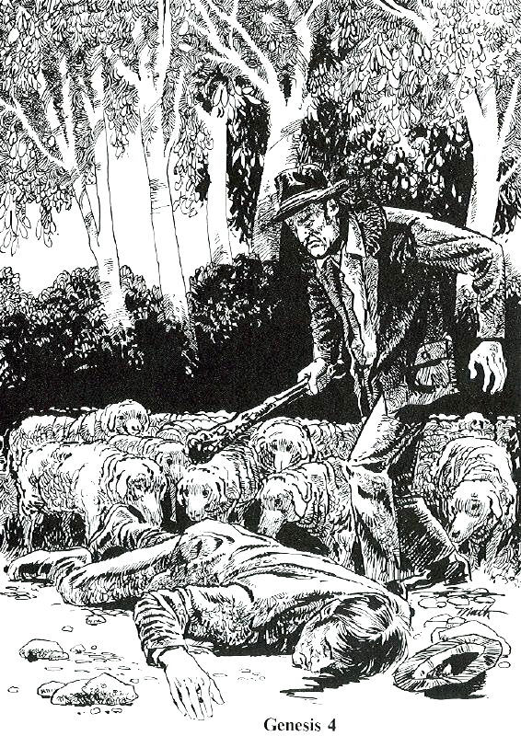

Read Genesis 4:1-16
1. What is the most extreme way to break the 5th Commandment?
2. How did God try to help Cain control his anger?
3. What did Cain do? Was he sorry for what he had done?
4. What two things make Abel's murder so horrible?
5. List some of the key elements the artist included to help us understand this story:

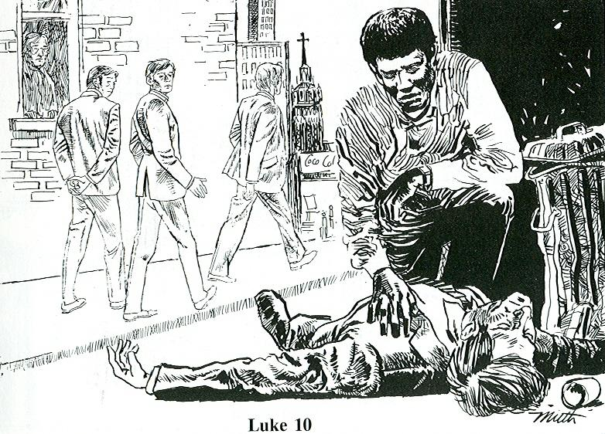

Read Luke 10:25-37
1. What is the setting for the artist's picture?
2. What are some of the things that prevent the bystanders from helping?
3. Who stops to help?
4. Who is our neighbor?
5. What does the 5th commandment tell us to do for our neighbor?

The King will reply, “I tell you the truth, whatever you did for one of the least of these brothers of mine, you did for me.” Matthew 25:40

